11. Connect the computers in Local Area Network.
Connection and transfer of data are some of the invaluable uses of a computer. A lot of technology has arisen from this dire need. Between computers, one effective method is via the use of Ethernet or LAN cables. Here we walk you through all the steps to establish a LAN cable connection between two Windows 10 PCs for file-sharing or data transfer.
Advantages of LAN Cable Connection
One of the main advantages with connecting two Windows 10 laptops or computers is that it provides a medium to share files when you don’t have access to a wireless network.
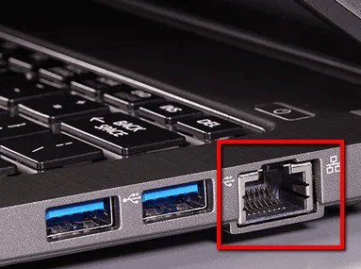
If you do not trust the available Wi-Fi network, then you can make use of a LAN cable to connect the Windows 10 PCs and share files between them. The process is simple, and you only need to connect both the PCs with LAN cable and tweak a few network settings. It is a nice way to share files locally.
Choosing Between Straight or Crossover Cables
To know which cables will get the work done, you should first determine which devices you want to connect: are they the same kind of devices (two computers, for example) or different kinds of devices (a computer to a network switch or Ethernet hub, for example).
When two like systems share files, one outputs the data while the other receives it as input. Intentionally crossed wiring in the crossover cable connects the transmit signals at one end to the receiver signals at the other end. This makes crossover cables more ideal for an Ethernet connection between similar systems, like two computers.
How to Connect Two Windows 10 PCs with a LAN Cable
With a crossover cable in hand, connect both the PCs. Once done, follow the steps below.
- 1. Go to “Control Panel -> Network and Internet -> Network and Sharing Center -> Change Adapter Settings.”
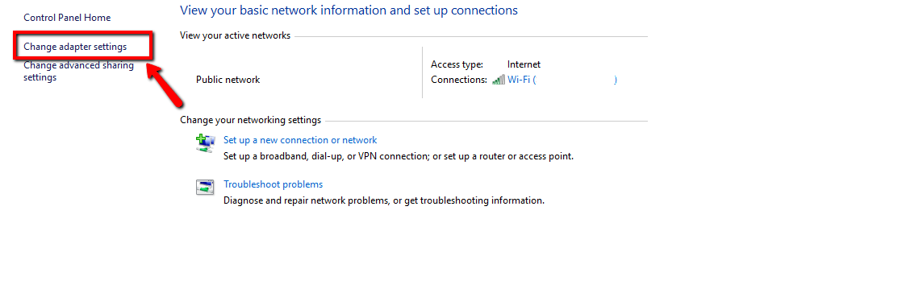
2. Click on “Change Adapter Settings.” This will reveal different connections. Select the appropriate connection for your LAN. Usually, but not necessarily, the connection will be called Ethernet.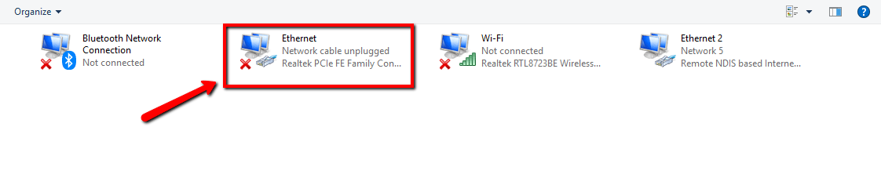
3. Right-click on the connection and select “Properties.” The local area’s connection properties window will appear.
4. Under the network tab, select “Internet protocol version 4 (TCP/IPv4),” then click on “Properties.
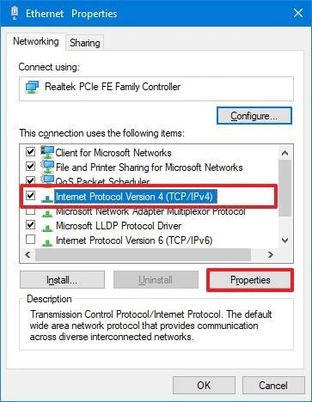
In the Properties menu, set the IP address and subnet masks of the first computer to:
• IP – 192.168.0.1
• Subnet Mask – 225.225.225.0
Repeat all the above steps for the second computer and set the IP address and subnet Mask as follows:
• IP – 192.168.0.2
• Subnet Mask – 225.225.225.0
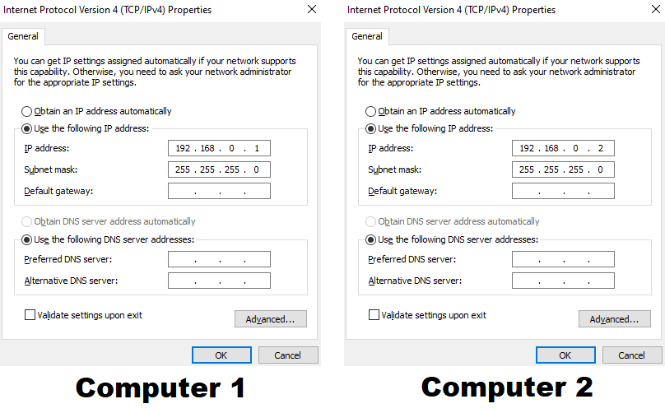

File & Printing Sharing
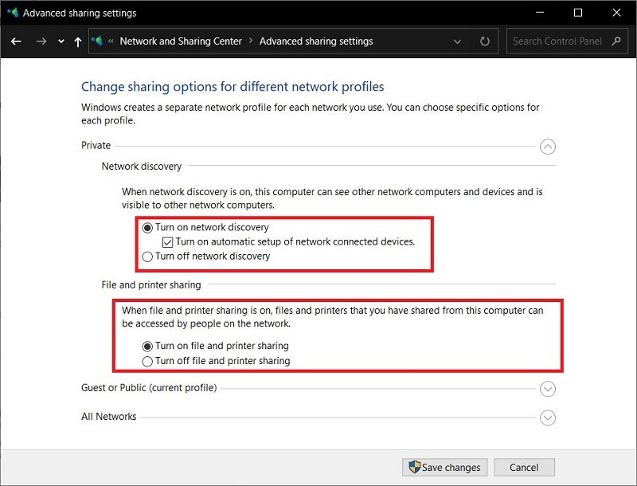
You can also tick the File and printer sharing option. This would allow the other Windows 10 PC to access the files and printers shared on the network.
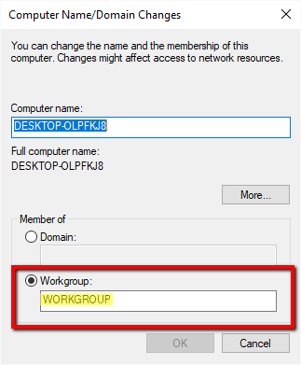

8. Right-click on the drive you want to share. Scroll to the “Give access to” option and click “Advanced Sharing.” Under the sharing tab, click the “Advanced Sharing” button.
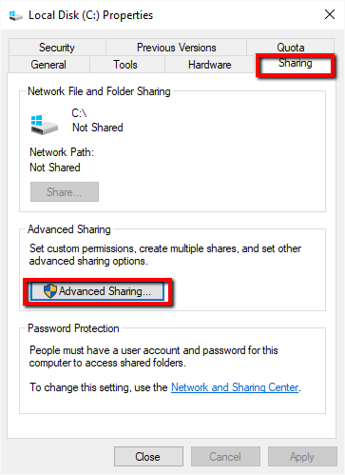
This reveals the advanced sharing window. Check the “Share this folder” checkbox and click “Apply -> OK.”
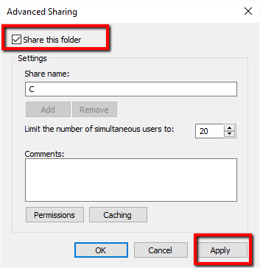
Transferring Files
You can now transfer specific folders or files between the two connected Windows 10 PCs. To share specific folders or files from Computer A (ADMIN-HP) with Computer B, follow the steps below:
1. Right-click the desired folder or file in Computer A. Scroll to the “Give access to” option and click “Specific People.”
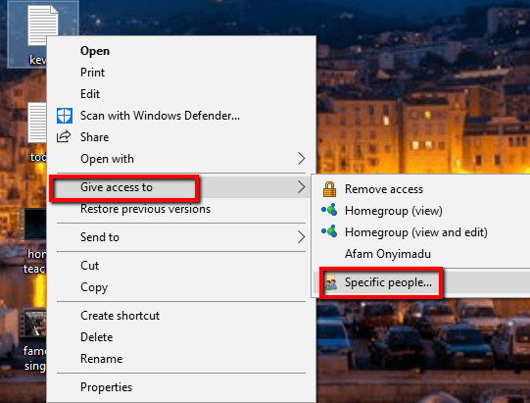
21. In the newly opened Network Access windows, select “Everyone” from the drop-down menu. Next, click “Add” and click “Share.”
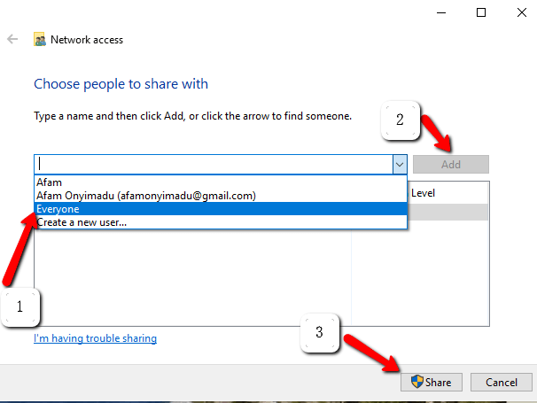
3. Similarly on Computer B, you need to open This PC and click on the Network option in the left pane. Here you will see the names of connected computers, part of the network. In this case, Computer A is ADMIN-HP. Double-click on it and all files shared will be displayed. At this stage, you can use the normal copy and paste to move the desired content.

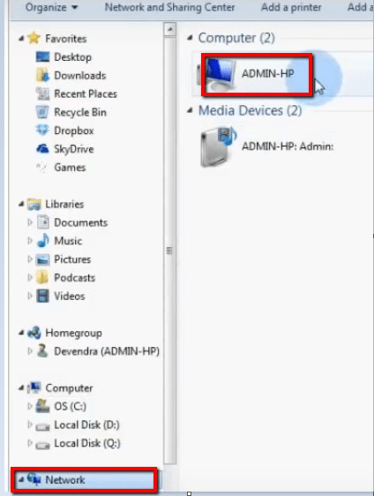
4. If you wish to copy files from Computer B to Computer A, you have to perform the same steps, but this time the steps previously performed on Computer A needs to be performed on Computer B and vice versa.

